**Name:- Samreen Shaikh Roll no:- 64**

**Subject:- Big Data Analytics Date:- 10/01/2025**

**PRACTICAL - 10**

**CASSANDRA INSTALLATION**

**INSTALLATION:**

**STEP I: *Install java version higher than jdk-11 and set the environment variable.***

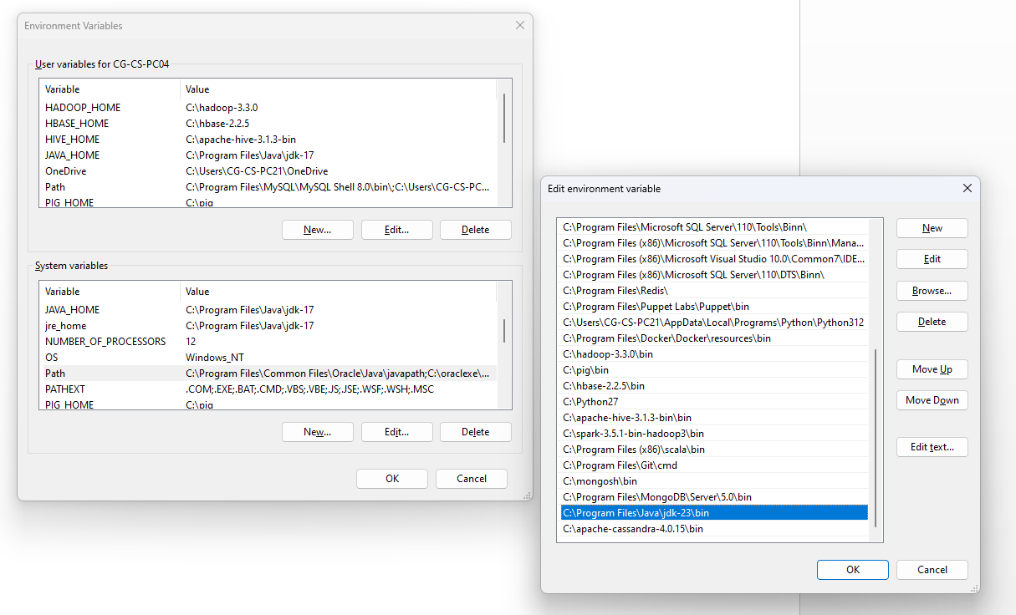

**STEP II: *Install latest python version and setup the environment variable.***

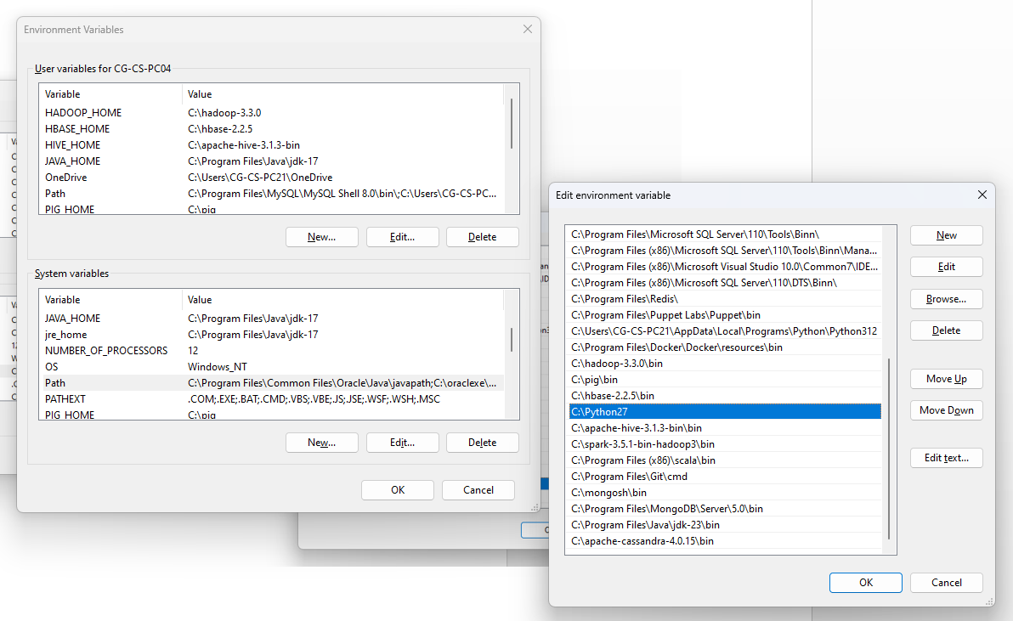

**STEP III: *Install the following Cassandra Version.***

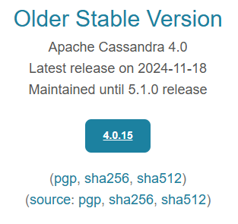

**STEP IV: *Set up the path in System variable of the Environment variable.***

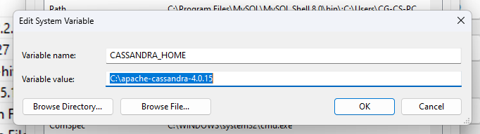

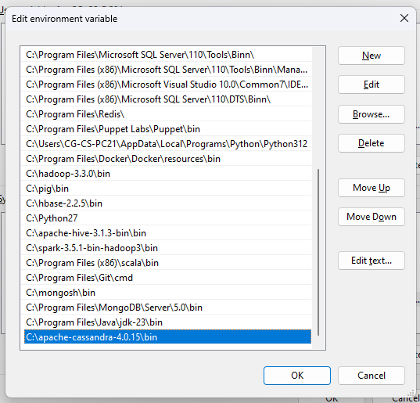

**STEP V: *Navigate to the bin directory in the apache-cassandra folder and open the command prompt.***

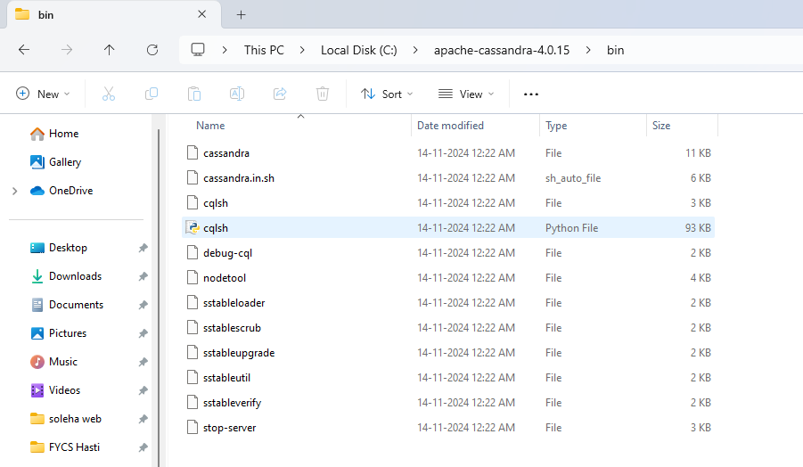

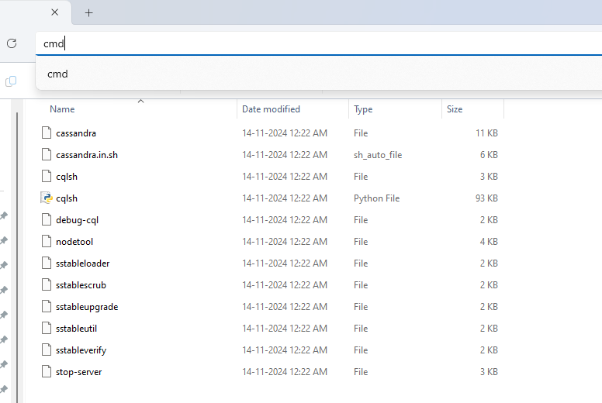

**STEP VI: Write the command “cassandra” to start the Cassandra.**

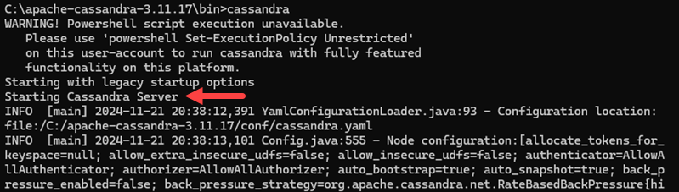

**STEP VII: *Access Cassandra cqlsh from Windows CMD.***

While the initial command prompt is still running, open a new command line prompt from the same bin folder. Enter the following command to access the

**Cassandra cqlsh bash shell:**

**cqlsh**